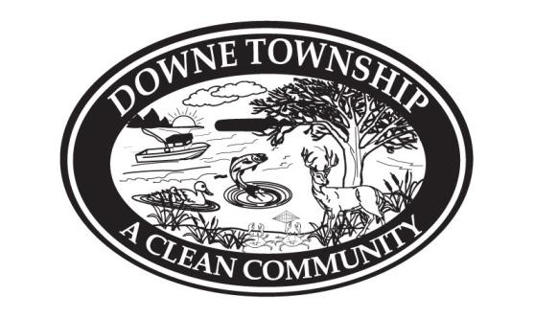
TOWNSHIP OF DOWNE
CUMBERLAND COUNTY, NEW JERSEY

 | YES | NO | ABSTAIN | ABSENT  Resolution Number: R-62-2020  Dated:  Offered By:  Seconded By:
Bart, E.
Bryne, S.
Burt, S.
Rothman, M.
Campbell, R.

RESOLUTION
UNINTENTIONALLY
LEFT BLANK

