Downe Twp Recreation & Tourism Committee

Holly Jolly Christmas Contest Entry Form
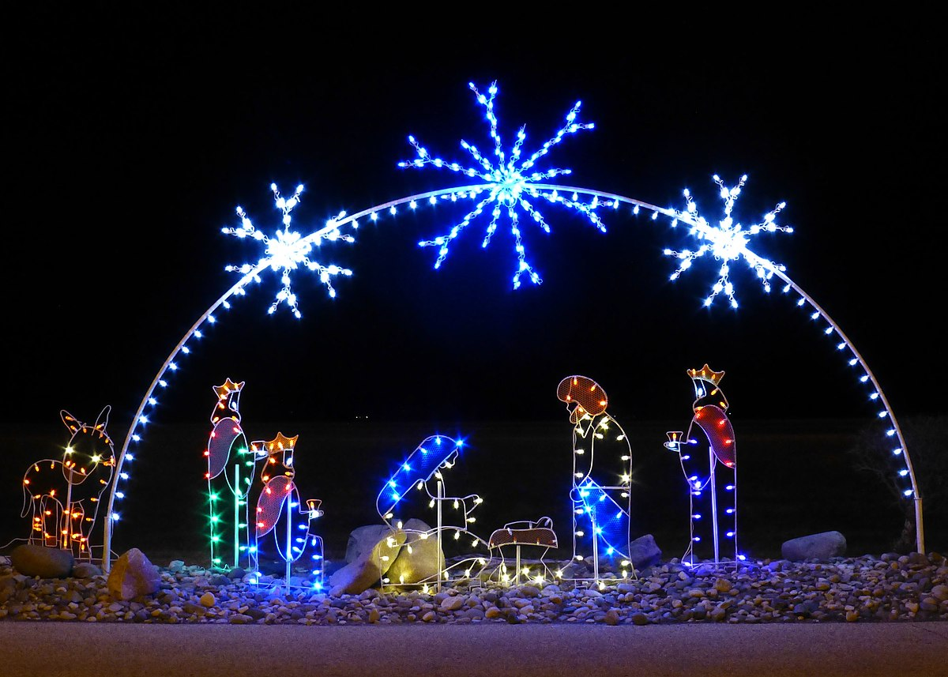
Name: _______________________________________________________________________
Address: _____________________________________________________________________
Phone #: _____________________________________________________________________
Email: _______________________________________________________________________
Submit Completed form to DowneTwpRec@gmail.com or drop off to Municipal Clerk.

